**FLT First Generation Optical Flow+IMU Module**

**Version 1.0**

**Overview**

FLT releases a new low-cost, high-performance, low-latency, full-featured planar positioning sensor of optical flowmeter + positioning module. This module integrates optical flow tracking sensor, triaxial accelerometer, three-axis gyroscope and one low-power microprocessor.

It can provide positioning information output on multi-material surfaces (such as tiles, floors, blankets, etc.). It can output based on starting position displacement increment calculated by internal sensor fusion algorithm and based on local geographic coordinate system 3D bearing data (Pitch、Roll、Yaw), can output all sensors' raw data simultaneously.

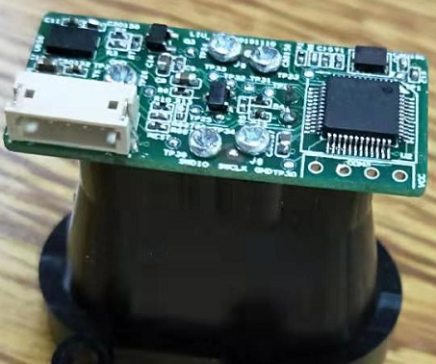

**Typical Application**

* Provide positioning and orientation information for indoor service robots and cleaning robots.
* Provide accurate positioning information for smart toys.

**Main features**

Base on optical tracking sensor high-precision positioning sensor.

Can adapt to most of different kind of surface materials in indoor scenes.

Able to adapt to faster exercise speed.

Small heading sensor based on MEMS sensor.

Integrated high-precision six-axis gyroscope.

Use stable and accurate sensor fusion algorithm to calculate the positioning information on the device

can output positioning, orientation and other information simultaneously

Extremely high stability against ambient temperature and external vibration.

UART interface with high-speed baud rate and data output frequency.

Low host configuration requirements.

Low power consumption.

**Diagram：**

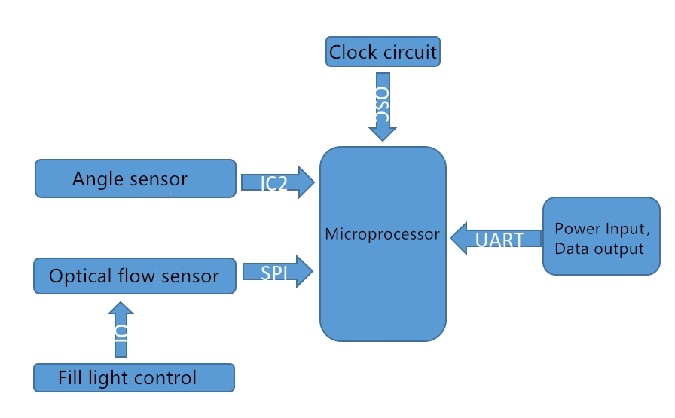

**Working condition:**

|  |  |  |  |  |
| --- | --- | --- | --- | --- |
| Parameter | Symbol | **condition** | Rate | Unit |
| Operating  Voltage | VCC |  | 3.3V +/-0.15V | V |
| Operating  temperature | TA |  | -20 ～ +70 | ℃ |

**Absolute Maximum Rate:**

|  |  |  |  |  |
| --- | --- | --- | --- | --- |
| Parameter | Symbol | **condition** | Rate | Unit |
| Supply voltage | VDD |  | 0-3.8 | V |
| Static Protection | ESD | HBM | 2 | KV |
| Storage  temperature | Tstg |  | -40 ～ +125 | ℃ |

1. Pin description

**external pin diagram of optical flow meter**

|  |  |  |  |
| --- | --- | --- | --- |
| **Pin** | **Name** | **I/O** | **Features** |
| 1 | 3.3V | I：Input | Power（3.3V DC） |
| 2 | TX | I：Input | UART send data |
| 3 | RX | O：Output | UART receive data |
| 4 | GND | -- | ground |
| 5 | RST | -- | System reset |

**2、Coordinate system**

Imu coordinate system,its sensitive axis is perpendicular to the device area (see below), thus, its sensitive axis rotates will occur an exact angular rate (and angular increment).

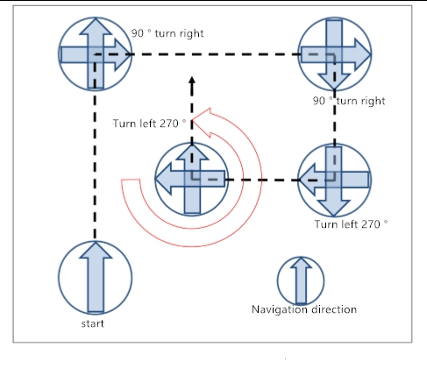

**E**xplanation：(Roll,Pitch, Yaw)

Pitch is up and down like a box lid.

Yaw is left and right like a door on hinges.

Roll is rotation.

**3.Specification**

|  |  |
| --- | --- |
| Dimension | 15.24mm x 17.78mm x 3.1mm |
| Displacement（X、Y direction） Resolution | 1 mm |
| （Pitch） Resolution | 0.01°(MAX.) |
| （Roll）Resolution | 0.01°(MAX.) |
| （Yaw）Resolution | 0.01°(MAX.) |
| （Pitch）range | ±90° |
| （Roll）range | ±90° |
| （Yaw）range | ±180° |
| With LASER light source error | 1% (MAX.) |
| With LED light error | 3% (AVE.) |
| Course angle error | 20°/hr (MAX.) |
| Angular rate error | ±900°/sec (MAX.) |
| Angular rate movement error | ±0.01°/sec (MAX.) |
| Output frequency | 100Hz |
| Power | ~17.5mA (@3.3V) |
| Input voltage | 3.3V DC |
| Working temperature | -20 ~ 70℃ |
| Storage temperature | -40 ~ 85℃ |

**4. Communication Protocol**

UARTConfiguration as followings ：

Baud rate：115200；8 bit data length；Parity NONE；1 bit stop bit.

Optical flow+IMU GPS module provides angular velocity、 angular velocity and in a plane displacement output ，50 data packet/second（output frequency 50Hz）.data packet format definition as following ：

|  |  |  |  |  |  |  |  |  |  |  |  |  |  |
| --- | --- | --- | --- | --- | --- | --- | --- | --- | --- | --- | --- | --- | --- |
| Headers | | Data | | | | | | | | | | | |
| System time | | | | Pitch | | Roll | | Yaw | | GyroZ | |
| 0XFF | 0XFD |  |  |  |  |  |  |  |  |  |  |  |  |

|  |  |  |  |  |  |  |  |  |  |  |  |  |  |
| --- | --- | --- | --- | --- | --- | --- | --- | --- | --- | --- | --- | --- | --- |
| Data | | | | | | | | | | | | | Checksum |
| Led_mode_imu_status | Motion | IQ | | SumX | | | | SumY | | | | temperature |
|  |  |  |  |  |  |  |  |  |  |  |  |  |  |

|  |  |  |
| --- | --- | --- |
| **Output data** | **Byte** | **Explaination** |
| Headers | 1-2 | 0xFFFD |
| （Sytem Time） | 3-6 | Unit ms；  Measurement Range 0~4,294,967,296ms. |
| （Pitch） | 7-8 | True Angle times 100，Unit deg；  detection range ±90deg. |
| （Roll） | 9-10 | True Angle times 100，Unit deg；  detection range ±90deg. |
| （Yaw） | 11-12 | True Angle times 100，Unit deg；  detection range ±180deg. |
| Z Shaft angular velocity（GyroZ） | 13-14 | True Angle times 100，Unit dps;  detection range ±1000dps. |
| Led_mode_imu_status | 15 |  |
| Motion | 16 |  |
| IQ | 17-18 |  |
| SumX | 19-22 | Unit mm；orientation range -2,147,483,648~2,147,483,647mm. |
| SumY | 23-26 | Unit mm；  Location range -2,147,483,648~2,147,483,647mm. |
| Temperature | 27 | True temperature deducts 30 and multiply by 2 ；  detection range -40℃~85℃ |
| Checksum | 28 | =SysTime+Pitch+Roll+Yaw+GyroZ  +Led_mode_imu_status+Motion +IQ+SumX+SumY+ temperature |

* First byte is low-order byte

Network packets sample as follows ：

|  |  |
| --- | --- |
| **Name** | **Instructions / comments** |
| Packets | 0XFF FD 53 2C 06 00 C8 FF 25 0A A1 14 10 B2 00 80 0C 01 4F FF FF FF 7A EE FF FF FB 2C |
| （System Time） | 0x00062C53(HEX) = 404563  time = 404563/1000 = 405s |
| （Pitch） | 0xFFC8(HEX) = -56  angle = -56/100 = -0.56deg |
| （Roll） | 0x0A25(HEX) = 2597  angle = 2597/100 = 25.97deg |
| （Yaw） | 0x14A1(HEX) = 5281  angle = 5281/100 = 52.81deg |
| Z shaft angle speed | 0XB210(HEX) = -19952  Angular velocity = -19952/100 = -199.52dps |
| Led_mode_imu_status | 0X00(HEX) = 0 |
| Motion | 0X80(HEX) = 128 |
| IQ | 0X010C(HEX) = 268 |
| SumX | 0XFFFFFF4F(HEX) = -177  X Directional displacement= -177mm |
| SumY | 0XFFFFEE7A(HEX) = -4486  Y Directional displacement = -4486mm |
| Temperature | 0XFB(HEX) = -5  temperature = -5/2+30 = 27.5℃ |
| Checksum | checksum=0x53+0x2C+0x06+0x00+0xC8+0xFF+0x25+0x0A+0xA1+0x14+ 0x10+0xB2+0x00+0x80+0x0C+0x01+0x4F+0xFF+0xFF+0xFF+0x7A+0xEE +0xFF+0xFF+0xFB = 0x2C |

**Led_mode_imu_status explanation**：

**IMU Zero deviation calibration state：**

Led_mode_imu_status & 0X03 = 0，IMU Successful calibration（ highest precision）；

Led_mode_imu_status & 0X03 = 1，IMU zero-offset tilt angle is too big；

Led_mode_imu_status & 0X03 = 2，IMU止zero-offset non-stationary；with additional error process handling. Course angle is very accurate even with non-stationary.

Led_mode_imu_status & 0X03 = 3,IMU zero-offset tilt angle is too large or non-stationary.

**Optical flow meter LED status：**

Led_mode_imu_status & 0X04 = 0，LD light source( indicator light off)；

Led_mode_imu_status & 0X04 = 1，LED light source(indicator light off )。

In additional，optical flow+IMU GPS module UART interface provides four command：RESET HEADING、RESET BIAS、RESET IMU and RESET ALL。

Details as followings:

For instance，sending $HRST*，can set the course angle YAW to zero；

sending $CGYR*，can reset IMU static deviation；

sending $CIMU*，can set the course angle YAW to zero and reset IMU static deviation.

； sending $CALL*， all output of reset Module（Same effect as power-on initialization).

Optical flow meter test mode：

sending $TLDD*，Appointed use LD light；

sending $TLED*，Appointed use LED light；

sending $AUTO*，Appoint automatic light source switching.

**Optical flow meter test mode status：**

Led_mode_imu_status & 0X18 = 0，appoint automatic light source switching；

Led_mode_imu_status & 0X18 = 8， appointed use LD light ；

Led_mode_imu_status & 0X18 = 24，appointed use LED light.

Instructions：

“$HRST*”only reset heading angle as 0；

“$CGYR*”re-calibration IMU Static Deviation（Accelerometer and gyroscope），the value of Pitch、Roll and Yaw is the value before calibration ；

“$CIMU*” reset IMU partial output ，Pitch、Roll and Yaw reset as 0；

“$CALL*”Reset optical flow+IMU all outputs of the module，system time all reset as 0。

Problem：“$CGYR*”。Due to re-calibration, The actual angle difference between Pitch (or Roll) is large before and after calibration, it may occur angular drift.

**Importance：**

**It takes 3 seconds to zero the command，module must be stationary during zero offset.**

**Consider keeping the module away from heat and vibration sources.**

**Considering place a thermal insulation material to cover the module to avoid rapid temperature changes.**